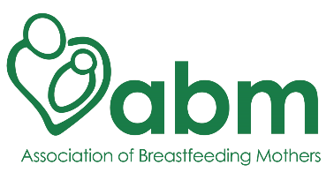

REFERENCE
The ABM provides breastfeeding support training to volunteers and health professionals. Our training is mostly distance learning, so the training team rarely meets a student in a face-to-face situation. Because of this, we ask each potential student to provide a reference from someone who holds a position of responsibility. It may be someone you have worked with, or volunteered with, but she/he should be someone who has seen you interacting with others and fulfilling responsibilities, whether or not this included supporting new mums, parents and families. A family member isn’t an appropriate referee.

# Name of applicant:
# Name of referee:
# Referee’s job title:
# Referee’s place of work:
# Referee’s email:
# Referee’s telephone number: we may contact you to discuss the application

# How long have you known the applicant and in what capacity?

# How would you describe the applicant’s character?

# How would you describe the applicant’s interaction with other people?

# Do you think she will be able to support breastfeeding mothers and parents on successful completion of the training?

# Are you aware of the applicant having undertaken any other training/activities eg. Midwife or doula training?

# If you have any reservations or if you have any other information you would like us to know about the applicant, please tell us here:

To the best of my knowledge, the information I have provided is complete and accurate.

# Referee’s signature: (a typed signature is acceptable)
# Date:

Please return this reference as an attachment (rather than in the body of an email or as a downloadable link, titled ‘Applicant’s Name Ref” to the applicant.

Thank you for your time.

Association of Breastfeeding Mothers, PO Box 1052, Taunton, TA1 9RY
www.abm.me.uk
Registered charity no: 1193445

