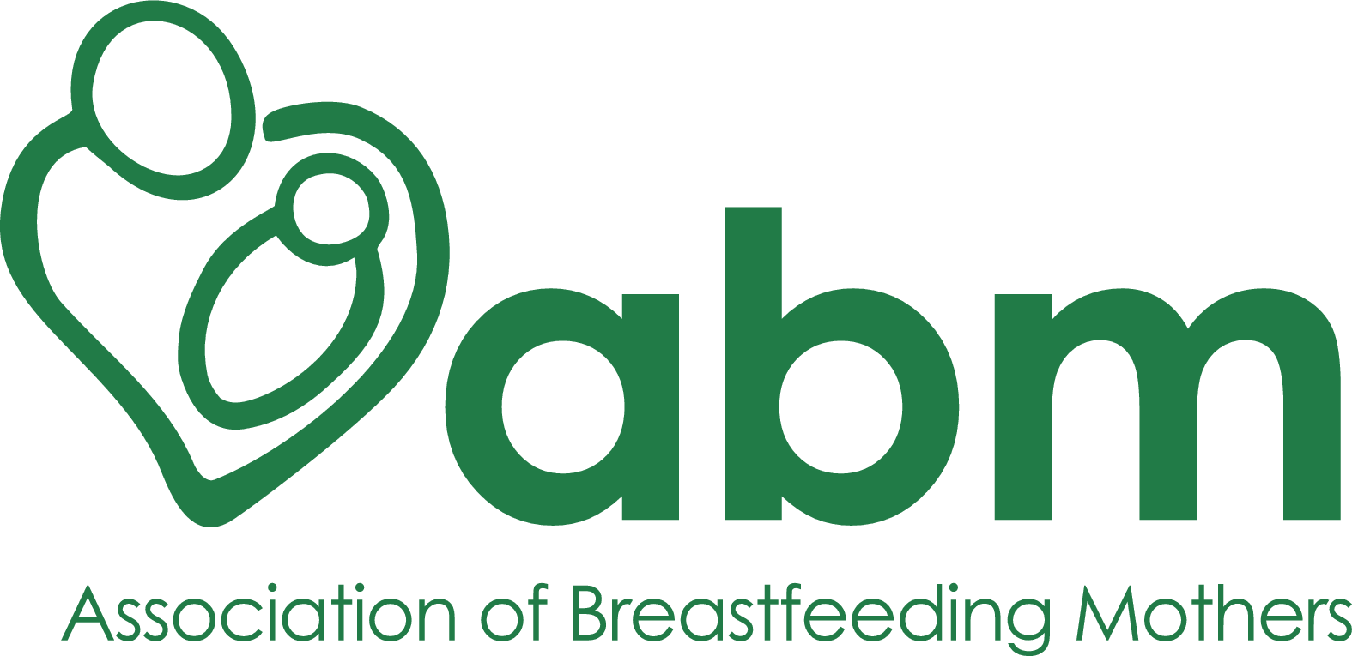

Volunteer Role Description
May 2026

Date last reviewed: Oct 2021
Next review due before: 31 Oct 2022
Person responsible: Caroline Bolton

ABM Voluntary Role Description
ABM role title | ABM BFC/ADVANCED MODULE MARKER
ABM role reference | BFCADM26
Date | 27/05/2026
Responsible person | Caroline Bolton

Background of post:
This is a flexible volunteer position of approximately 2 hours per week.
The ABM Breastfeeding Counsellor and Advanced Course training is an integral part of the ABM. BFC, when qualified, answer calls, social media and webchat messages on the National Breastfeeding Helpline. Our Advanced graduates have Health Professional and family related roles both in and out of the NHS.
The ABM BFC and Advanced course consists of eight modules. Once completed, these are directed to a marker who will assess the module. Markers will receive a marking scheme to guide them and receive initial group and individual training and ongoing support as required.

Main duties:
- Be able to assess and give positive feedback on areas where the trainee has done well. Be able to ask for extra clarity or more detail on areas without negatively impacting on confidence.
- Respond to trainees and ABM within a given timeframe.
- Update the ABM Trainee Spreadsheet on SharePoint.

Person Specification (those with an * are considered essential)

Experience, Knowledge and Skills
- Have up to date BFC status with the ABM. *
- An interest in breastfeeding education. *
- Understanding of cultural safety and inclusivity in the ABM training. *
- An understanding of the relationship between the National Breastfeeding Helpline and the ABM.
- Understand the differences between face to face and telephone/message based support. *
- Ability to use Office 365 and update spreadsheets. *
- Time and flexibility to deal with busy and quiet periods depending on the number of modules. *
- Ability to communicate clearly and concisely with trainees and other ABM Training Team members. *
- Understanding of referencing methods and the importance of up to date evidence based references. *
- An understanding of when to refer back to the Training Team if there are any unresolved issues. *
- Able to join update and team meetings throughout the year.

