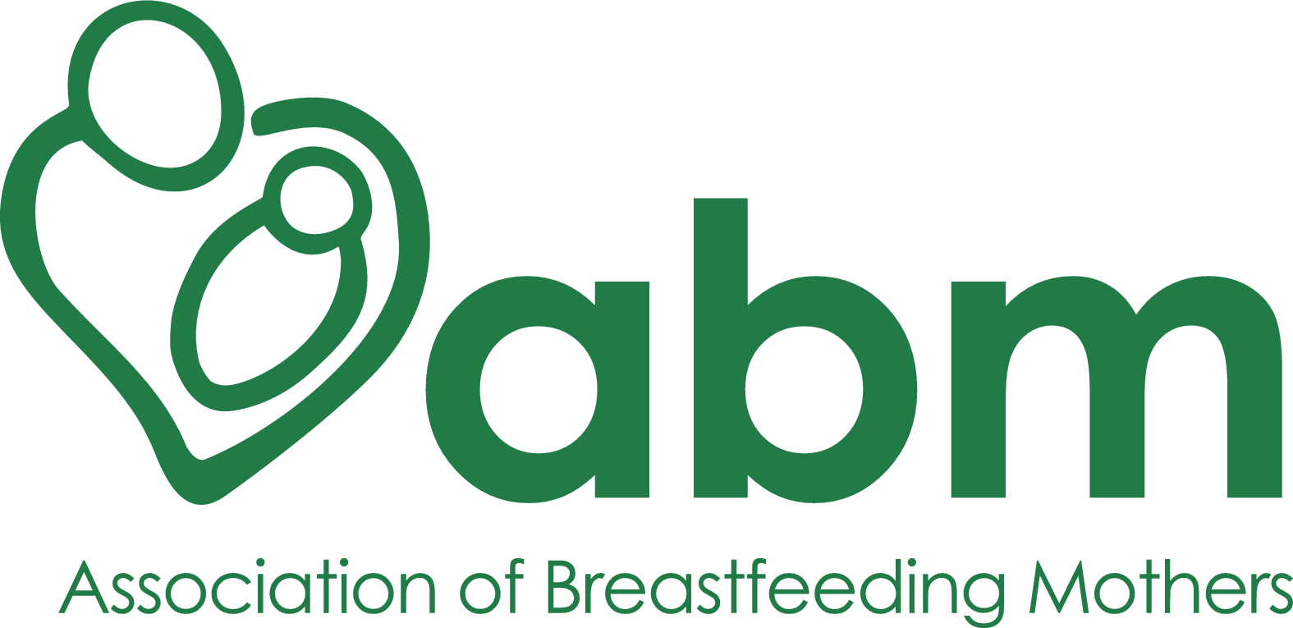

ABM PEER SUPPORTER MENTOR (PSM)
APPLICATION FORM
January 2022

Date last reviewed: Oct 2021
Next review due before: 31 Oct 2022
Person responsible: Caroline Bolton, Caroline Harrower

Private and Confidential
Application for Voluntary role
Please complete this application form and check it carefully before returning it by email to admin@adm.me.uk

Voluntary position details
ABM role Title
ABM role reference
Person responsible

Personal Details
Last Name
First Names
Address
Postcode
Country
Preferred contact telephone number
Email Address

Referee
Who is your PS mentor or BFCC? We may contact them for a reference.

Conflicts of Interest
If you work or volunteer with families for services or products relating to pregnancy, birth or early years, you must disclose this below. It is important to keep different roles separate from potential work within ABM.
Please confirm all your paid work and / or volunteering is within the WHO Code: Yes / No

Do you have any accessibility or other requirements?
If you require large print or alternative means of accessing this information, or will need reasonable adjustments to the application process, please let us know.

Relevant training and courses (Please add additional rows if you need to)
Training Provider | Course Title

Relevant Experience (You may add additional pages if necessary)
Please give details including dates and details of organisation, role and duties.

Supporting Information (You may add additional pages if necessary)
Please tell us why you want to apply for this role. Please refer to the Role Description for this role.

DECLARATION
The information in this form is true and complete. I agree that any deliberate omission, falsification or misrepresentation in the application form will be grounds for rejecting this application for volunteering with the ABM. Where applicable, I consent that the organisation can seek clarification regarding professional registration details. I also agree that I have the time and equipment necessary as per the Role Description to undertake the role.
I agree to the above declaration
Signature
Name |  | Date

