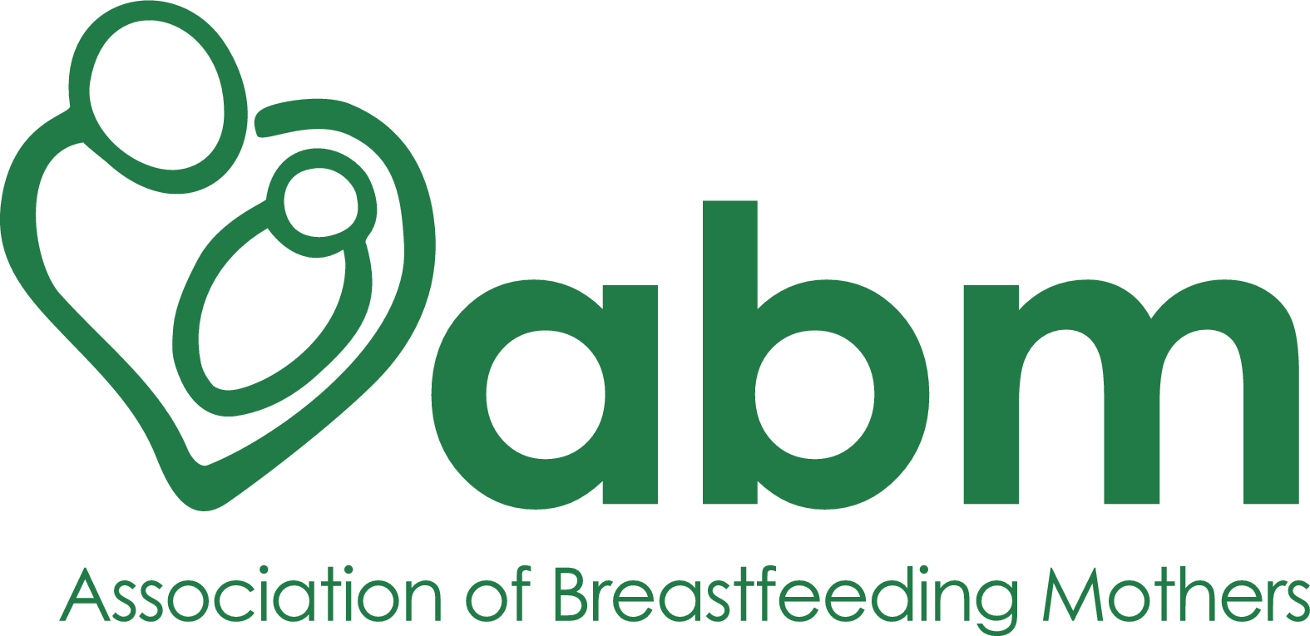

ABM REFERENCE FORM

Date last reviewed: 24th March 2022
Next review due before: 31 March 2023
Person responsible: Caroline Bolton

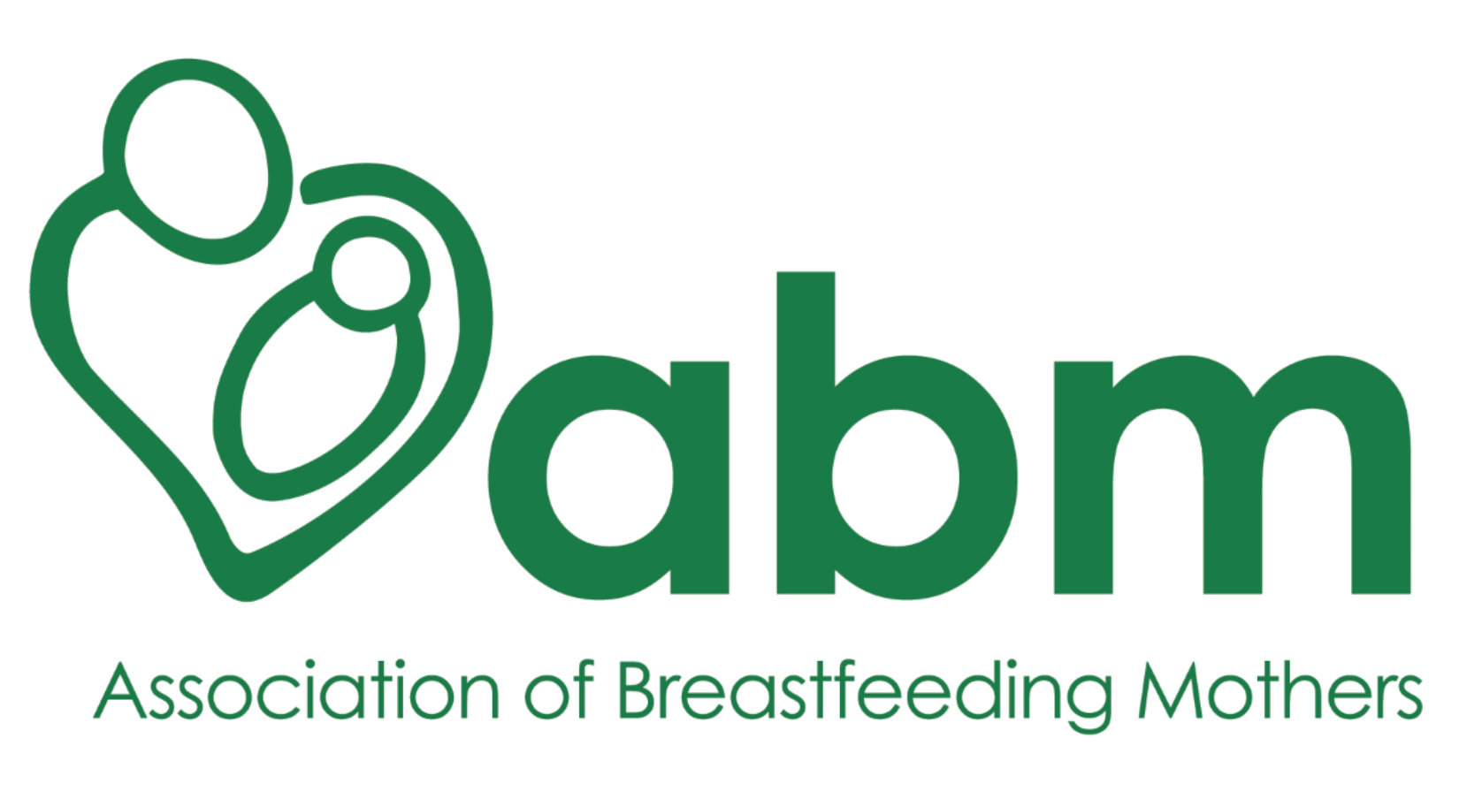
Reference

The ABM provides breastfeeding support training to parents, families and health professionals. Our training is mostly distance learning, so the training team rarely meets a student in a face-to-face situation. Because of this, we ask each potential student to provide a reference from someone who holds a position of responsibility. It might be someone you have worked with, or volunteered with, but they should be someone who has seen you interacting with others and fulfilling responsibilities, whether or not this included supporting new parents and families. A family member or friend isn’t an appropriate referee.

- Name of applicant:
- Name of referee:
- Referee’s job title:
- Referee’s place of work:
- Referee’s email:
- Referee’s telephone number:

How long have you known the applicant and in what capacity?

How would you describe the applicant’s character?

How would you describe the applicant’s interaction with other people?

Do you think they will be able to support breastfeeding mothers and families on successful completion of the training?

[for breastfeeding counsellor applicants only] ABM breastfeeding counsellors must agree to answer helpline calls for at least two years after completion of training. Do you think the applicant will fulfil this helpline commitment?

If you have any reservations or if you have any other information you would like us to know about the applicant, please tell us here

To the best of my knowledge, the information I have provided is complete and accurate.

Referee’s signature: (a typed signature is acceptable)
Date:

Please return this reference to: admin@abm.me.uk or by post to the address below.
Thank you for your time.


Your reference will be seen by members of the ABM training team only and will be stored on a password-protected cloud-based server.

Association of Breastfeeding Mothers, PO Box 1629, Bedford, MK42 5EF
www.abm.me.uk
Registered charity no: 280537

