**ABM BREASTFEEDING COUNSELLOR APPLICATION FORM**

**Date last reviewed: 24th March 2022**

**Next review due before: 31 March 2023**

**Person responsible: Caroline Bolton**

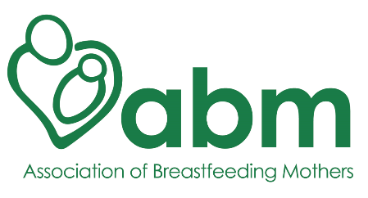

**Training application for the ABM Breastfeeding Counsellor course**

Please note PS / BFC status is not valid outside of the UK. If a PS / BFC changes their residency to outside the UK or is temporarily out of the UK for longer than three months, then their status is no longer valid and is revoked. This applies to training status also.

Name:

Address:

Email:

Phone:

*Expand these sections as you type in your answers.*

*You’re welcome to give as much information as you wish.*

**1.** When did you complete your ABM Peer/Mother Supporter module?

**2.** What is your occupation/role?

**3.** Please write an account of your experiences and reflections since starting the ABM Peer/Mother Supporter module.

**4.** Why do you want to train as a breastfeeding counsellor with the ABM?

**5.** Do you speak any other languages fluently? If so, which ones?

**6.** If you have a role (voluntary or paid) with an organisation associated with babies and toddlers, it’s important that your organisation is compliant with the *WHO International Code of Marketing of Breast Milk Substitutes*. If applicable, please give a brief explanation of your organisation and your role within it. How do you plan to combine your existing role with that of a volunteer ABM Breastfeeding Counsellor?

**7. REMINDER**

If you, or any of your close family members, are involved in commercial activity or paid work related to infants and/ or infant and young child feeding, we ask you to declare it here. It may not be a bar to your role with the ABM provided:

[a] This activity does not contravene the International code on the marketing of breastmilk substitutes (commonly known as the WHO code [https://www.who.int/…/in…/breastmilk-substitutes-FAQ2017/en/](https://www.who.int/nutrition/publications/infantfeeding/breastmilk-substitutes-FAQ2017/en/?fbclid=IwAR0Dk3Ae4ndDdF3OlLGeTTpC1W5DucS0t7kVp2TR8WAmw34DQt20k-PXbKo)).

[b] You understand that the role of an ABM volunteer requires you to be evidence-based when communicating with families and commercially neutral in your discussion of products and businesses.

However, if an involvement is not declared at this stage, this could jeopardise your involvement with the ABM in the future. We ask you to contact us should your situation change.

**8.** I confirm that I fully intend to commit to answering NBH/ABM helpline calls for at least two years after qualifying as an ABM Breastfeeding Counsellor.

**9.** The name of my referee is:

**10.** Mentoring Peer Supporters

Would you be willing to take on a mentoring role for ABM Peer Supporters? As a trainee BFC with the ABM we would value your help to mentor and administer the trainee Peer Supporters. This involves basic regular admin and communications with the Peer Supporters allocated to you. Are you interested in this vital role which compliments your training? Yes/No

We will contact you if you are accepted to give you more details.

Please return your completed form to [admin@abm.me.uk](mailto:admin@abm.me.uk)

We’ll acknowledge your application within two weeks. NB. Your BFC modules will need to be completed in WORD (not pdf or pages, for example). Please ensure you have the relevant software installed.

Your Breastfeeding Counsellor Coordinator (BFCC) will be in touch to arrange a practise helpline call and interview.

Your application will be viewed only by members of the ABM training team, and will be saved on a password protected cloud-based server.

Personal details will be stored securely. If you’ve mentioned any details about your children as part of your personal history, please let us know if you give us permission to store these details.

END